Activity No. 2.2
Control Structures (part 1)
Course Code: CPE 007 | Program: Computer Engineering
Course Title: Programming Logic and Design | Date Performed: 8/11/25
Section: CPE11S1 | Date Submitted: 8/11/25
Name(s): Paula G Esguerra | Instructor: Engr. Jimlord Quejado
6. Output
Exercise 1: Counter- Controlled Repetition. A class of ten students took a quiz. The grades (integers in the range of 0 to 100) for this quiz are available to you. Determine the class average on the quiz. Put your answer in the output section of the activity template. Ensure that the screen shot of the code and the output are readable.

Using the following pseudocode the program can be as follows:

Set total to zero

Set grade counter to one

While grade counter is less than or equal to ten

Input the next grade

Add the grade into the total

Add one to the grade counter

Set the class average to the total divided by ten

Print the class average

Counter controlled repetition is often called definite repetition because the number of repetitions is known before the loop begins executing. In the example above, the number of grades (10) was known in advance. What if there is no indication is given of how many grades are to be entered? How can the program determine when to stop the input of grades? How it will know when to calculate and print the class average?

One way to solve this is to use a special value called the sentinel value (also called a signal value, a dummy xvalue or a flag value) to indicate “end of data entry”. The user types grades in until all legitimate grades have been entered. The user types the sentinel value to indicate that the last grade has been entered. Sentinel-controlled repetition is often called indefinite repetition because the number of repetitions is not known before the loop begins executing.

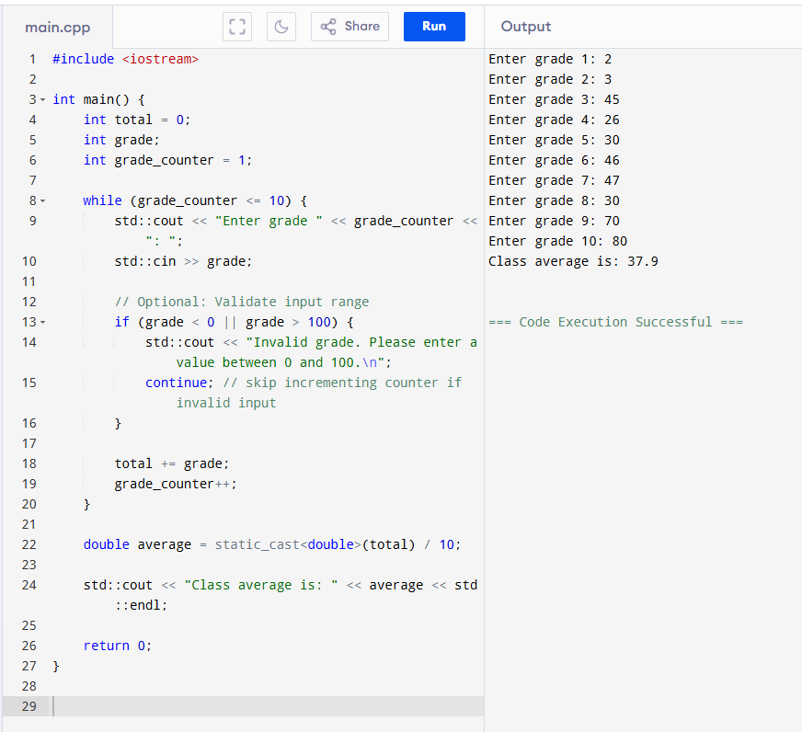
7. Supplementary Activity
- Using conditional statements (if-else statements), write a program that asks a user for a number and prints out if it is an even or an odd number.
Pseudocode:

Initialize total to zero

Initialize counter to zero
Input the first grade

While the user has not as yet entered the sentinel

Add this grade into the running total

Add one to the grade counter

Input the next grade (possibly the sentinel)

If the counter is not equal to zero

Set the average to the total divided by the counter

Print the average

else

Print “No grades were entered”

/*Class average program with counter-controlled repetition */

#include<iostream>

using namespace std;

int main()

{

int counter, grade, total, average;

/* initialization phase */

total = 0;

counter = 1;

/* processing phase */

while (counter <=10){

cout<<"Enter the grade: ";

cin>>grade;

total = total + grade;

counter = counter + 1;

}

/* termination phase */

average = total / 10;

cout<<"Class average is" <<average;

return 0; /* program ends */

}

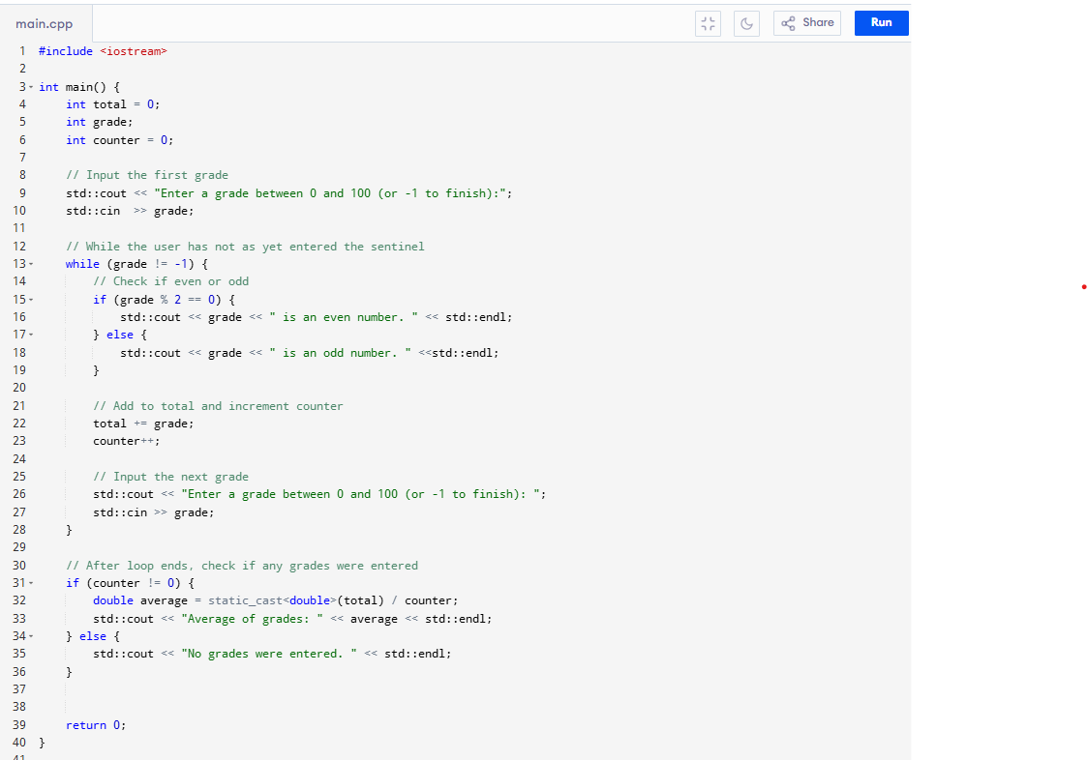
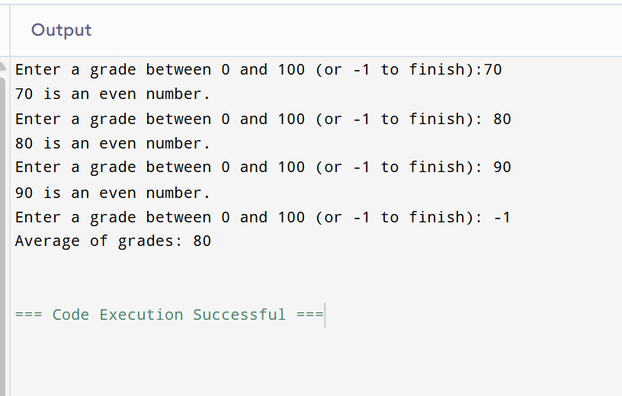

- Using conditional statements, write a program that computes for 10 percent fare discount of a senior citizen and 8 percent fare discount of a student. There will be no discount if not a senior citizen and not a student. The user will be asked to enter age. The minimum fare is 9 pesos.
Pseudocode:

Initialize total to zero

Initialize counter to zero
Input the first grade

While the user has not as yet entered the sentinel

Add this grade into the running total

Add one to the grade counter

Input the next grade (possibly the sentinel)

If the counter is not equal to zero

Set the average to the total divided by the counter

Print the average

else

Print “No grades were entered”

/*Class average program with counter-controlled repetition */

#include<iostream>

using namespace std;

int main()

{

int counter, grade, total, average;

/* initialization phase */

total = 0;

counter = 1;

/* processing phase */

while (counter <=10){

cout<<"Enter the grade: ";

cin>>grade;

total = total + grade;

counter = counter + 1;

}

/* termination phase */

average = total / 10;

cout<<"Class average is" <<average;

return 0; /* program ends */

}

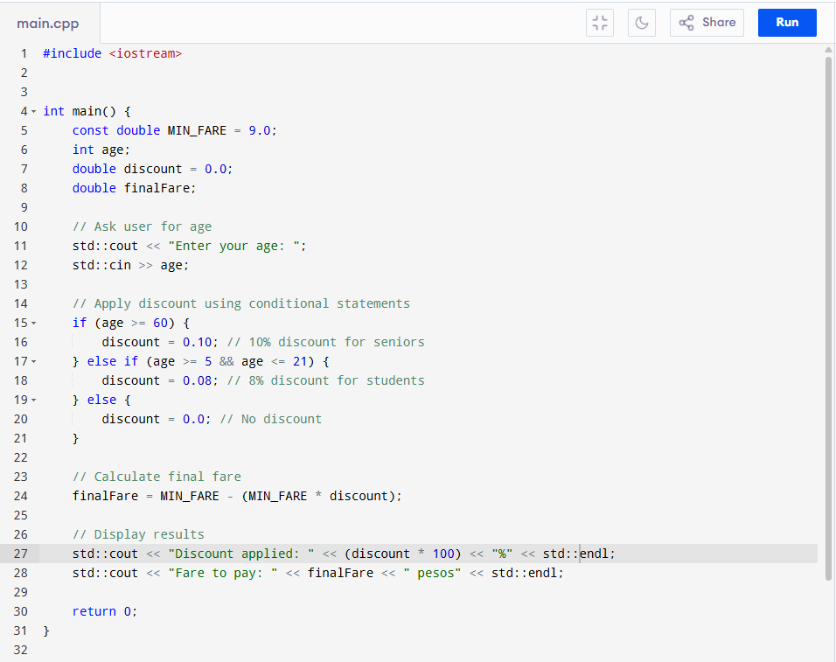
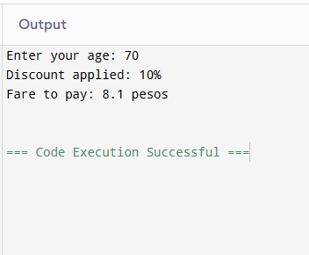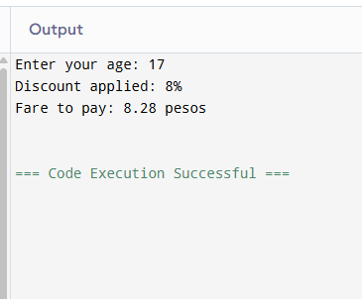

- Case Study: Sentinel Controlled Repetition. Given the following pseudocode, create a program that will implement a sentinel controlled repetition. For example, you can use (-1) as the sentinel value. You can use Problem 1 as your reference.

Pseudocode:

Initialize total to zero

Initialize counter to zero
Input the first grade

While the user has not as yet entered the sentinel

Add this grade into the running total

Add one to the grade counter

Input the next grade (possibly the sentinel)

If the counter is not equal to zero

Set the average to the total divided by the counter

Print the average

else

Print “No grades were entered”

/*Class average program with counter-controlled repetition */

#include<iostream>

using namespace std;

int main()

{

int counter, grade, total, average;

/* initialization phase */

total = 0;

counter = 1;

/* processing phase */

while (counter <=10){

cout<<"Enter the grade: ";

cin>>grade;

total = total + grade;

counter = counter + 1;

}

/* termination phase */

average = total / 10;

cout<<"Class average is" <<average;

return 0; /* program ends */

}

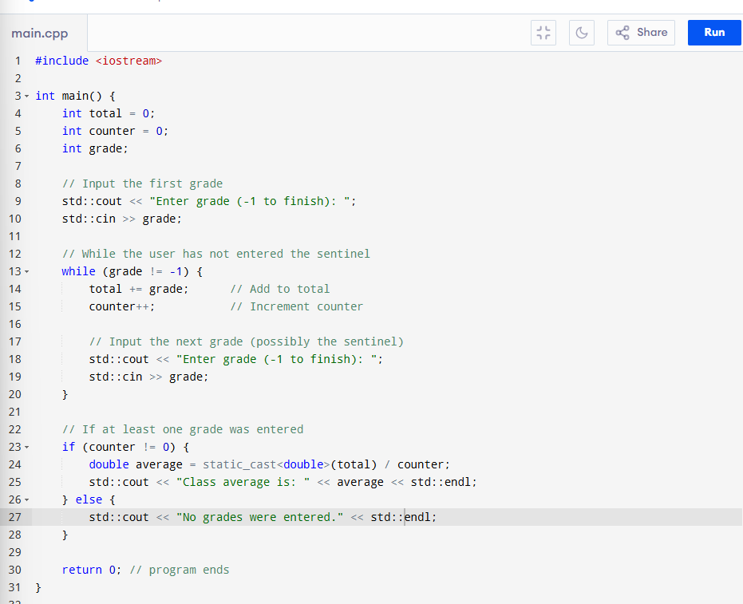
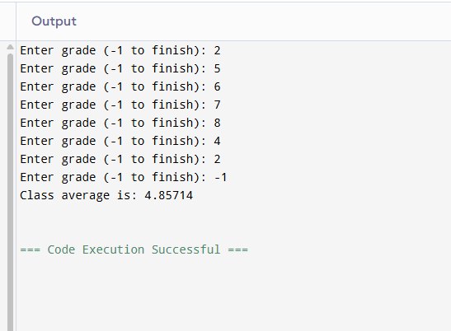

8. Conclusion
The if/else is used for evaluation of a condition, for example, == (equal to), > (greater than), < (less than), >= (greater than or equal to), <= (less than or equal to), and etc… This if/else maybe always be basing on the condition’s truth value. The while loop executes a specified condition that remains true, it uses the same conditions if/else use. The counter-controlled repetition is when the number of iterations is known in advance, tested against a condition and being updated. Sentinel-controlled repetition is the somehow the opposite of counter, is used when the number if iterations is unknown and depends on a specific condition and input. I learned how to use and mixing them into one code, if/else, while loop, and the repetitions.
9. Assessment Rubric
